Can Money Buy Happiness?
Michaela Kasparcova

Abstract
Mental health is a growing topic of discussion today. This study aims to investigate one of the possible causes of mental health disorders. Previous research has shown there to be a relationship between monetary resources and depression. This study examined data of each country’s national average income, gross domestic product, and depression rate. The predictor variables were national average income and gross domestic product, while the response variable was depression rate. The variables were then used in a model that was created using multiple regression. The p-value of 0.1117 draws the conclusion that average income and GDP are not significant in predicting depression rate. The main implication was that not every country has adequate mental health professionals to accurately diagnose the population with depression. Future research has the suggestion to collect data of individuals that possibly exhibit symptoms of depression along with those clinically diagnosed.

Introduction
Mental health has become a popular topic in our society today. Mental health is the state of mental well-being that allows the individual self to overcome the stresses of life and work toward their most prosperous self, as defined by the World Health Organization. What an individual does in their daily life impacts their mental health (Geschwind et al., 2022). Consequentially, an individual’s daily life is determined, to a certain extent, by the monetary resources available (Corcoran et al., 2021). Scholars have previously determined that living in low-income conditions has a negative effect on mental health (Corcoran et al., 2021; Patel et al., 2018; Hou et al., 2022). A majority of these previous studies focused on a sub-set of the population and/or used different demographics. Additionally, other scientific research on this topic used dissimilar predictors and response variables. Some of these predictor variables included participants having a household income of $20,000 or less (Corcoran et al., 2021), the Gini coefficient (Patel et al., 2018), and Centre for Epidemiologic Studies Depression Scale (CES‐D) (Patel et al., 2018), to name a few. Some of the response variables included were overall life satisfaction (Hou et al., 2022), as well as self-reporting and clinical measures (Corcoran et al., 2021). Even though different variables were used, all the studies concluded similar results (Corcoran et al., 2021; Patel et al., 2018; Hou et al., 2022). However, missing from previous research is the inclusion of entire countries’ populations rather than using sub-sets of the population.
However, there are a few possible implications of these results. The first would be that there is missing or not updated information for each country. Some countries do not have the capability to accurately measure the average income, GDP, and/or depression rate. Secondly, since these variables may take time to calculate, the most current data may not be available. Consequently, countries who do not have data for all three variables found within the last five years will be excluded from this study. An additional implication would be that the data uses the population of clinically diagnosed individuals to calculate the percentages (World Population Review, 2023). However, countries that have superior healthcare systems are more likely to successfully diagnose an individual with depression (World Population Review, 2023). This disconnect could possibly impact the data. Even taking these possible implications into account, this research has the potential to make significant strides in the understanding of the causes for depression. The results can greatly impact overall mental health by allowing governments to focus on an underlying monetary cause for depression in their country and combat it.
Research Questions
This research study will look at each individual country as its own population to examine the relation between wealth and depression. This study will investigate how a country’s average income and GDP influence the country’s depression rate. The goal of this study is to use different countries’ data to seek the relationship between the availability of monetary resources and depression.
Statement of Purpose
The overall purpose of this study is to explore the connection between financial resources and mental health. Previous research only focused on sub-set groups, whereas this study can apply to countries’ total populations. These results could have a major impact on how monetary resources are distributed and how depression is a direct result of that distribution of funds.

Literature Review
It has been said that money can buy happiness. But can it really? For this research project, I am going to investigate the relationship between money and happiness. Each country in the world has data on national average income and national GDP, which I will be using for each country as predictor variables. Unfortunately, happiness is not something that can be easily measured quantitatively. This is why I will be using each country’s depression rates as the response variable. My plan is to use multiple regression to conduct this study and explore this correlation.
The initial article reviewed was the “Prevalence of depression in women with low income living in developed countries” (Corcoran et al., 2021). This research took a deep dive into adult women who are living in low-income conditions. The research itself was conducted over one hundred and sixty-four studies with 218,035 participants involved (Corcoran et al., 2021). The women that were selected to participate were eighteen or older, pregnant, post-partum, or at any other stage in adult life (Corcoran et al., 2021). Defining these women as low-income meant that they lived below the federal poverty line, were eligible for safety net programs, and had a household income of $20,000 or less (Corcoran et al., 2021). The study found these women as depressed, through a combination of self-reporting and clinical measures. There were a variety of studies then conducted which took into account country, ethnicity, and pregnancy status (Corcoran et al., 2021). The results of these studies showed that the rates of depression are statistically significant (Corcoran et al., 2021). This particular report collected data from all of these different research studies and drew results from them. The conclusions reached from this research were that there is a high rate of depression for women who live in low-income conditions (Corcoran et al., 2021). It was found that depression in this demographic is of “serious public health” concern (Corcoran et al., 2021).
The relationship between income and depression has been researched to include a population larger than just women. The second article of interest conducted a research study that took a broader lens in studying the relationship between income inequality and depression. Wealth and income have been unequally distributed and there is substantial “evidence linking income inequality with mental health outcomes” (Patel et al., 2018). The review included twenty-six studies from relatively high-income countries (Patel et al., 2018). The measure for income inequality that was used in a majority of the studies was the Gini coefficient, and the measure of depression was the Centre for Epidemiologic Studies Depression Scale (CES‐D) (Patel et al., 2018). Two-thirds of the studies included found that there is a significant positive relationship between low-income individuals and the risk of depression (Patel et al., 2018). Another three studies reported a slightly less strong positive relationship, six studies found there to be no relationship, and one study found there to be a negative relationship (Patel et al., 2018). The conclusion that was drawn is that there is a significant relationship between low-income populations and increased risk of depression (Patel et al., 2018). The article stressed that there should be a governmental move to reduce income inequality and that mental health professionals should be a part in that process (Patel et al., 2018).
While I was finalizing my search, I came across an interesting article conducted by researchers in China. This article investigates the relationship between multidimensional energy and poverty and depression in adults in China. The study uses energy poverty as a predictor variable which “is mainly reflected in the low level, poor structure, and weak capacity of energy use for domestic purposes” (Hou et al., 2022). There are multiple different dimensions that contribute to energy poverty including, but not limited to, owning a car, owning a refrigerator, and having heating facilities (Hou et al., 2022). These different variables are referred to as the MEPI of older adults (Hou et al., 2022). The response variable for this research is life satisfaction, which is measured on a scale from one to five (Hou et al., 2022). The study came to four relevant conclusions. The first conclusion is that “multidimensional energy poverty has aggravated depression among older adults” (Hou et al., 2022). The second conclusion is that energy poverty has a greater effect on individuals in the western region of China (Hou et al., 2022). The last two conclusions are that depression is more prevalent for adults living in solitary without family members and that multidimensional energy poverty in older adults reduces overall life satisfaction (Hou et al., 2022).
All the studies have similar research goals. They looked at low-income individuals to test the impact their socioeconomic status had on their depression. However, there are no distinct differences in research. The first study focused on adult women living in low-income conditions, using a smaller research group. In contrast, the second article examined many different studies over a broad population. The third study took place in China, so it only included individuals located in China. Each study had different variables and ways to measure the impact of those variables. For the predictor variables, the first study uses the federal poverty line, the second uses the Gini coefficient, and the third study uses MEPI. For the response variable, the first study uses self-reporting and clinical measures, the second uses the Centre for Epidemiologic Studies Depression Scale (CES‐D), and the third uses overall life satisfaction. Although there was a difference in variables, the results of all three studies yielded similar results. Each of the studies reported a relationship between income and depression. Research concludes that living in poverty can negatively impact mental health therefore increasing one’s susceptibility to becoming depressed or staying depressed. So, can money buy happiness? While we may not be able to guarantee that money buys happiness, research suggests that a higher income can help prevent depression. Instead of asking, “Can money buy happiness?” should we be asking, can money prevent depression?

Methodology
Participants
The population in this study is each country that has viable data for average income, GDP, and national depression rate. The data taken from World Population Review (2023) will contain the country name, mean yearly income in international dollars, and GDP per capita in international dollars. International dollars are defined as a “theoretical dollar often used in country-to-country comparisons” (World Population Review, 2023). The response variable data is from World Population Review (2023) as well and calculates percentages based on the number of clinically diagnosed individuals divided by the country’s population. The data will use each country as an individual case in this sample. As previously mentioned, disqualifying characteristics include not having adequate data within the last five years for each of the three variables. After the data has been cleaned, it will contain one hundred sixty-two observations.
Data Collection
This study will be using already existing data. The data in this study will be derived from the World Population Review. World Population Review (2023) used data from the World Health Organization (WHO) to create the dataset. The World Health Organization collected this data by working closely with “lead GBD researchers for mental and behavioral disorders (based at the School of Public Health, University of Queensland, Australia” (2017). This data will then be aggregated via CSV file and placed into RStudio to be used. The final dataset will contain every viable country, average income, GDP, and depression rate. However, this data set is not entirely clean as is. As previously specified, any country that does not have national average income, GDP, and depression rate values for within the last five years will be excluded from this study.
Variables
There are three main variables used in this study, one response variable and two predictor variables. The response variable is the depression rate, which will be referred to simply as depression rate in this study. This variable is quantitative and represents the number of clinically diagnosed individuals in a country divided by the population of that country. The depression rate will be included as a percentage. As for the two predictor variables, they are average income and Gross Domestic Product (GDP). For the first predictor variable, the data from World Population Review (2023) refers to average income as mean income. For this study, mean income will be referred to as average income. The average income is quantitative and is found by taking the sum of the income in a country and dividing it by the population of that country. The unit of measurement will be the international dollar, which was previously defined. The second predictor variable in this study will be Gross Domestic Product, which will be referred to as GDP. GDP is a quantitative variable and is found by measuring “the value of the final goods and services produced” (Bureau of Economic Analysis, 2022). The unit of measurement for GDP will also be the international dollar.
Statistical Modeling and Analysis Plan
To evaluate the relationship between monetary value and depression, the data for each country’s average income, GDP, and depression rate were assembled. There will be two different predictors explaining the response variable, therefore, multiple regression will be used for the model. The response variable ($Y$) represents the depression rate for the country. After taking the predictor and response variables into account, this following model will be used:
$$Y=β_{0}+β_{1}X_{1}+β_{2}X_{2}+E$$
where $X_{1}$ is the average income in international dollars for each country and $X_{2}$ is the Gross Domestic Product (GDP) in international dollars for each country. There are no variables that will be acting as a control variable in this model. This model is set in stone to an extent, and there will be no model selection techniques used. These techniques are not required because there is no categorical variable involved, no interaction variable, etc.
Regarding the technology that will be used, RStudio software will be used to analyze the data. All models, tables, and graphs will be derived from RStudio. When the data is put into RStudio, there are now 153 observations. Beyond the summary outputs from RStudio, other regression diagnostics will be used to further analyze the data. An ANOVA table will be used to help determine R-squared values and residual standard error. Additionally, a test for overall regression will be performed to examine how both predictors (average income and GDP) are related to depression rate. The goal of this test is to see if the set of independent predictors significantly contribute to predicting the response variable. Again, the overall goal of this study is to use different countries’ data to seek the relationship between the availability of monetary resources and depression. The descriptive statistics above will be used to determine whether there is a relationship. To answer this question, a combination of examining regression coefficients, R-squared values, and the results of the test for overall regression will be used.

Results
The goal of this study was to investigate the relationship between each countries’ financial value and the depression rate of the population. National average income and GDP were used to predict the depression rate of that country.
Descriptive Statistics
The response variable for this study is depression rate. Once more, the depression rate for each country is calculated by taking the number of individuals clinically diagnosed with depression divided by the total population of the country. The two explanatory variables are Average income in international dollars and GDP in international dollars. The mean for average income is 6,437.032 international dollars with 6,767.705 standard deviation, mean for GDP is 20,212.18 international dollars with 21,050 standard deviation, and the mean for depression rate is 4.427% with 0.689% standard deviation.
Inferential Statistics
Average income and GDP were used in the model previously described to gain coefficient outputs. The outputs for the coefficients from RStudio are shown below in Table 1. These two predictors were used in the model to conceive an Analysis of Variance table, as shown below in Table 2. In order to further analyze the data, scatterplots were created. The first one is average income plotted against depression rate (Figure 1). The second scatterplot is GDP plotted against depression rate (Figure 2).

Table 1
Coefficient Outputs
 | Estimate | Std. Error | t value | Pr(>|t|)
(Intercept) | 4.063e-02 | 6.485e-04 | 62.643 | <2e-16
income | 1.912e-07 | 2.325e-07 | 0.822 | 0.412
gdp | 1.196e-07 | 7.474e-08 | 1.600 | 0.112

The table yields a model that has every estimate value close to zero and contains a p-value of 0.112. These show that average income and GDP are not significant in predicting depression rate.

Table 2
Analysis of Variance (ANOVA) Table
 | Df | Sum sq | Mean sq | F value | Pr(>F)
income | 1 | 0.0020914 | 0.00209139 | 62.6862 | 4.854e-13
gdp | 1 | 0.0000854 | 0.00008538 | 2.5593 | 0.1117
Residuals | 151 | 0.0050378 | 0.00003336

The test for overall regression yields a p-value of 0.1117. The conclusion here is that average income and GDP are not significant in predicting depression rate. Not shown in either of the tables are the R-squared value and Residual Standard Error value. The R-squared value from RStudio is 0.3017, which is fairly insignificant. The Residual Standard Error value from RStudio is 0.005776 on 151 degrees of freedom. The Residual Standard Error represents the average amount that the response will deviate from the model. Therefore, having a low error is possibly significant. To further access the data, two scatterplots were created in R to observe the relationship of average income and depression rate and then GDP and depression rate by themselves.
Figure 1
Scatterplot of Average Income vs. Depression Rate
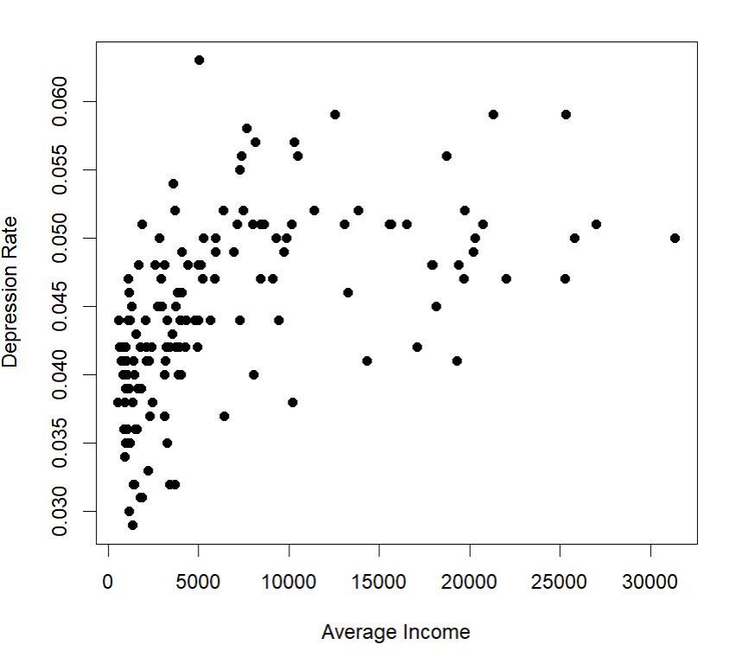
Figure 2
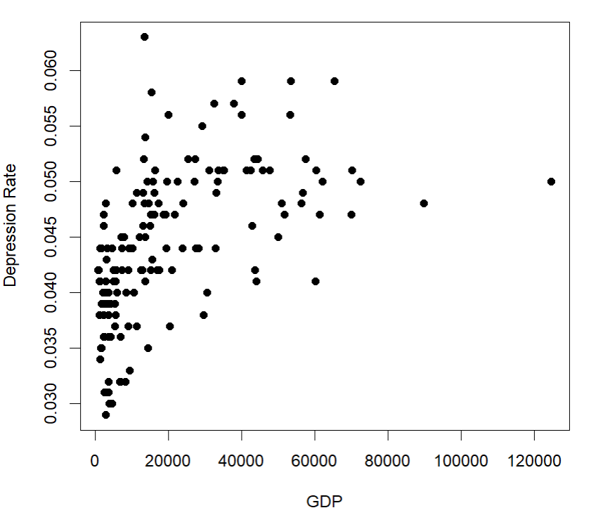
Scatterplot of GDP vs. Depression Rate

Each of the plots shows a positive correlation with each individual predictor and depression rate. This raises into question if just one of the predictors is necessary to predict depression rate. Further significant tests can be performed if necessary to possibly remove one of the predictor variables. Looking at the shape of the graphs, they both show a curved model. This could possibly indicate that a nonlinear model or a transformation of the data would be more appropriate.
Post-Hoc Analysis
There could be a possible cofounder for this data. In the data set, the value of depression rate was found through the number of individuals that were clinically diagnosed with depression. Countries that have less monetary resources, in turn, have less access to healthcare. Less access to adequate healthcare translates into fewer mental health professionals that are certified to diagnose individuals. That could be a possible cofounder within this data and could be the reason why the rates are lower for countries that have less financial freedom. This makes sense because countries that have less monetary flexibility are not going to use what little resources, they have on mental health professionals. The resources would rather go to other sectors of life.

Conclusion
The purpose of this study was to examine the relationship between money and happiness. The study did this by using each countries’ average income and GDP and compared it to the depression rate. The results had meaning to them, however, there are a few possible implications. Future research can examine these implications and work to develop better results.
Interpretation of Results
The results for this study were found to be statistically insignificant. Since the p-value was 0.1117 for the model, there can be no significant relationship between each countries’ average income and GDP when predicting depression rate. The results of this study yield that a country with more money does not necessarily have a lower rate of depression within its population. These results show that money does not buy happiness.
Limitations
There are two main possible implications that may arise throughout this research. First, as discussed in the Post-Hoc Analysis, every country does not have the same access to mental health professionals. And because depression rate in this study was based on individuals who were clinically diagnosed, this creates an implication. Secondly, the sample data that was used may not be accurately representative of the population. This is because countries that did not contain accurate results for all three variables found within the last five years were excluded from the data. Countries with fewer technological resources are more likely to not have all three data points. Therefore, this presents an implication for the results.
Suggestions for Future Research
This research has the potential to expand greatly in the future. One of the main suggestions for future research is to expand the data of depression rate greater than those clinically diagnosed. The data in this study only included individuals that were clinically diagnosed with depression. If future studies have the ability to collect data of individuals that possibly exhibit symptoms of depression along with those clinically diagnosed, that will remove many implications.

References
Bureau of Economic Analysis. (2022, April 26). Gross domestic product. U.S. Bureau of Economic Analysis (BEA). Retrieved March 12, 2023, from https://www.bea.gov/data/gdp/gross-domestic-product
Corcoran, Marinescu, I., Vogelsang, C., Kim, J. C., & Morgan, S. (2021). Prevalence of depression in women with low income living in developed countries. Depression and Anxiety, 38(10), 1046–1053. https://doi.org/10.1002/da.23208
Geschwind, Peeters, F., Jacobs, N., Delespaul, P., Derom, C., Thiery, E., van Os, J., & Wichers, M. (2010). Meeting risk with resilience: high daily life reward experience preserves mental health. Acta Psychiatrica Scandinavica, 122(2), 129–138. https://doi.org/10.1111/j.1600-0447.2009.01525.x
Hou, Zhou, W., & Jiang, Y. (2022). Multidimensional energy poverty and depression among China’s older adults. Frontiers in Public Health, 10, 977958–977958. https://doi.org/10.3389/fpubh.2022.977958
Patel, Burns, J. K., Dhingra, M., Tarver, L., Kohrt, B. A., & Lund, C. (2018). Income inequality and depression: a systematic review and meta‐analysis of the association and a scoping review of mechanisms. World Psychiatry, 17(1), 76–89. https://doi.org/10.1002/wps.20492
World Health Organization. (2017, January 3). Mental Health and Substance Use. Depression and other common mental disorders. World Health Organization. Retrieved March 12, 2023, from https://www.who.int/publications/i/item/depression-global-health-estimates
World Health Organization. (2022, June 17). Mental health. World Health Organization. Retrieved March 12, 2023, from https://www.who.int/news-room/fact-sheets/detail/mental-health-strengthening-our-response
World Population Review. (2023). Depression Rates by Country 2023. World Population Review. Retrieved March 12, 2023, from https://worldpopulationreview.com/country-rankings/depression-rates-by-country
World Population Review. (2023). Median Income by Country 2023. World Population Review . Retrieved March 12, 2023, from https://worldpopulationreview.com/country-rankings/median-income-by-country

